1.

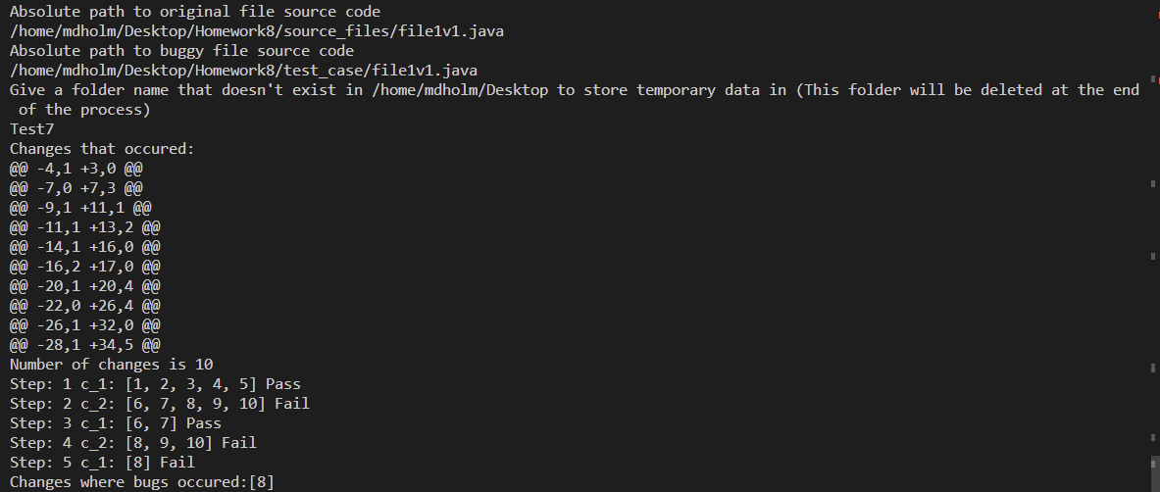

2.

|  |  |  |  |
| --- | --- | --- | --- |
| Step # |  | Configuration | Test |
| 1 |  | 1,2,3,4,5 | Pass |
| 2 |  | 6,7,8,9,10 | Fail |
| 3 |  | 6,7 | Pass |
| 4 |  | 8,9,10 | Fail |
| 5 |  | 8 | Fail |

3.

See Zip submission

4.

See Zip submission